

MD.Razia
M. Adith Kumar Reddy
2520030559
CSE
CO - 1

Case Study topic: HealthNet – Intelligent Health Resource Management System using AVL Tree

Work Done Summary:
In this case study, we implemented an AVL Tree for managing Netflix movie records.
The AVL Tree stores movie titles in sorted order and automatically maintains balance after every insertion.
We inserted multiple movie records into the AVL Tree and observed balancing operations such as LL, RR, LR, and RL rotations. We also implemented a movie search operation to retrieve movie information efficiently.

Implementation Details:
- Created an AVL Tree structure for storing movie titles.
- Inserted movie records into the AVL Tree.
- Calculated balance factors after every insertion.
- Performed AVL rotations whenever the tree became unbalanced.
- Maintained a balanced tree structure automatically.
- Implemented search functionality to locate movies quickly.
- Displayed AVL Tree information such as root node, height, and balance factor.
- Verified AVL property after all insertions.

Results and Screenshots:
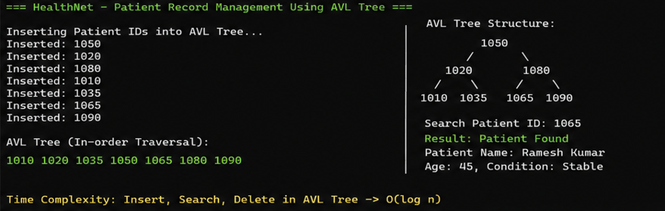
Time Complexity: AVL Insert, Search, and Delete operations are performed in O(log n) time due to automatic tree balancing.
Compared to a normal BST, the AVL Tree provides better worst-case performance because the tree remains balanced after every insertion and deletion.

GitHub Link: https://github.com/Adith471/DSA-2/tree/main

